On the KVM select “sQEdit 01” and log in with your Corp account. On the desktop, click the “sQEditv5.2 DM” icon.

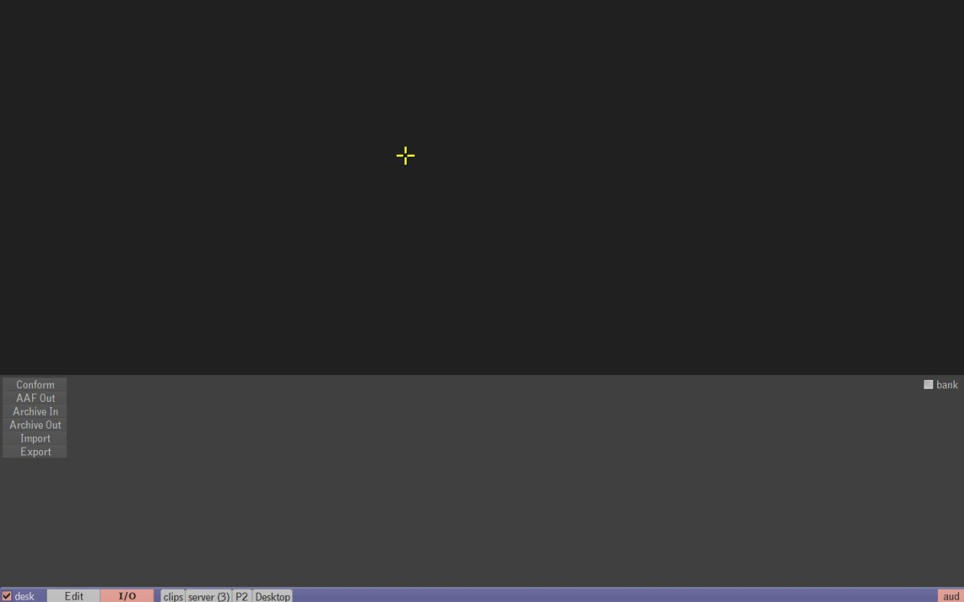

Click on the I/O Tab and select Export.

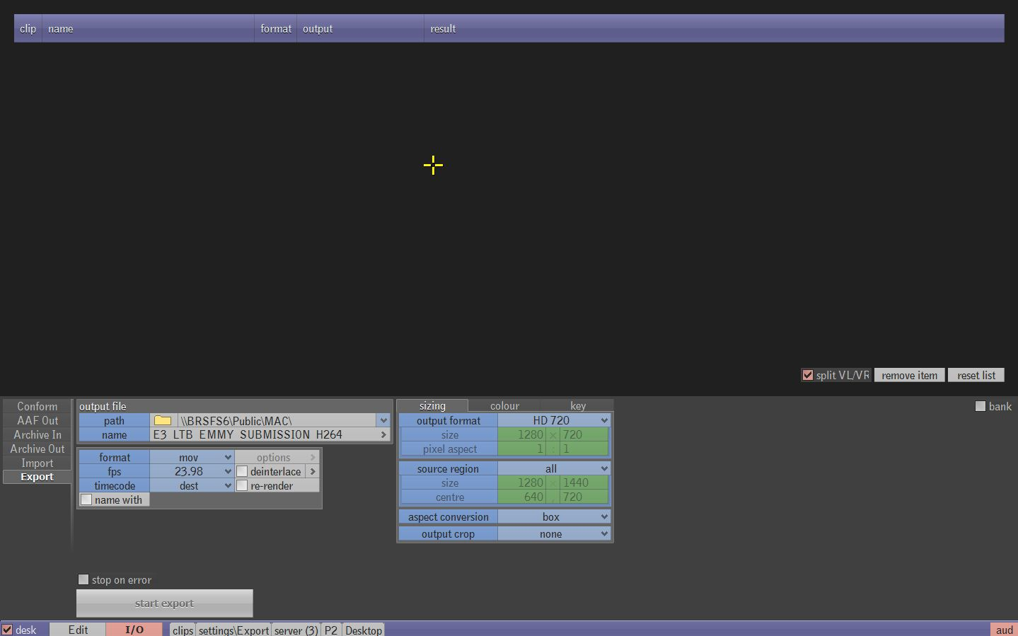

Several option boxes and a job list will appear.

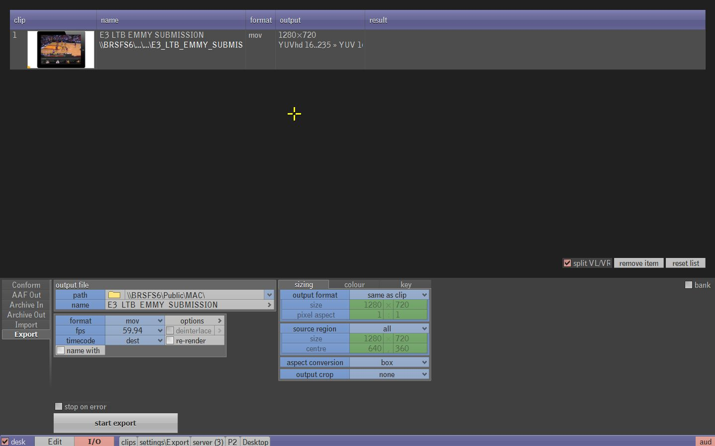

Use the server tab to find your clip on the server and drag it into the top of the export window.



The clip title will now appear in the “name” field below. Choose your save location in the “Path field”. We do have the ability to save directly to the P Drive by typing in \\BRSFS6\Public\ followed by the folder name. You will have to map the network drive under my computer first to do so. Any previously used paths will be saved under the dropdown arrow to the right on the field.

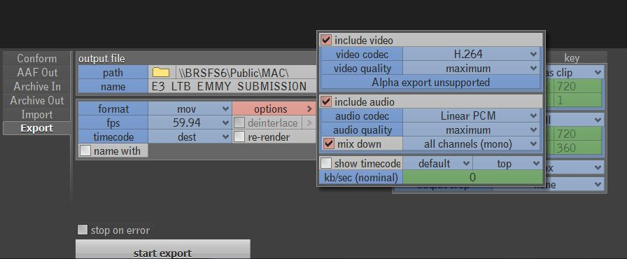

Next select your file format (.MOV, MPG, etc…) and click options to select your video/audio codec and video/audio quality.

  
Frame size and down conversion options are under the sizing tab. Set output format to “same as clip” to keep same settings as it appears on the server. Once you select your options, click “start export”

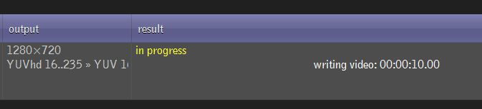

Your file will begin to export to your set save location. The result column will say success when complete.

**Trouble Shooting**

* If your file “fails” to export purge the cache. Hit F1 and go under the Server settings and click on the “Purge Cache” option. This should correct the issue.