**Selecting A UDX**

You can access all 11 UDXs from any one station. To change from one UDX to another, press and hold the **Remote** button. It will briefly scan and go to a menu screen that reads “**Remote Units**.”

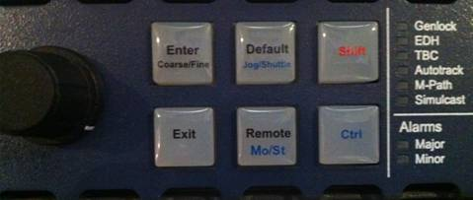

Using the scroll you can jog through all the UDX that we have. The last digit of the IP addresses is the UDX number. For example: X50 10.78.243.23 is UDX 3, X50 10.78.243.27 is UDX 7, and so on. The UDX are not in order, but just remember the last digit of the IP address is the UDX number. When you found which UDX you would like to set up, simply press in the scroll button or press the **enter** button.

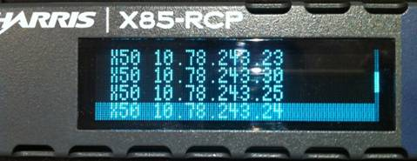

You will now be on that UDX’s **Main Menu v1.6.**

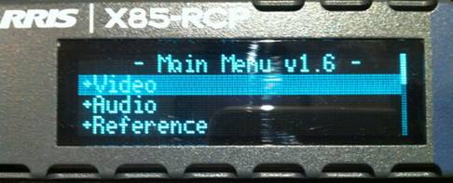

If you need to go to the previous screen, simply select **Exit** at any time.

**Cross Converting**

From the **Main Menu v1.6**, scroll down to **SDI1 Out Format**. Press in the scroll button or press **enter**.

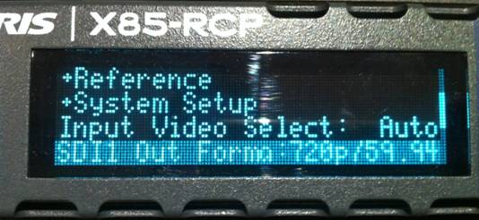

 This is where you select what that UDX will output. Scroll down and choose your format.

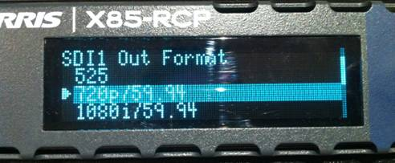

The UDXs can out put the following:

* 525
* 720p 59.94
* 1080i 59.94
* 1080p 23.98
* 1080sf 23.98
* 1080sf 29.97

 The input should always be set to Auto.

**Down Converting**

From the **Main Menu v1.6**, scroll down to **SDI1 Out Format** and set it to **525.** Once the output is set, select **Video.**

 (**Important Note**: If the output is not set to **525**, not all of the down converting options will appear)



Scroll down and select **Scalar 1**.

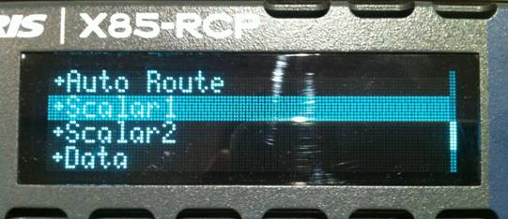

Scroll down to **ARC Preset** and press **enter**.

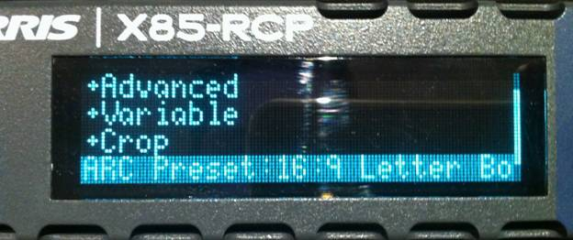

Scroll through and choose the down converting setting and press **enter**.

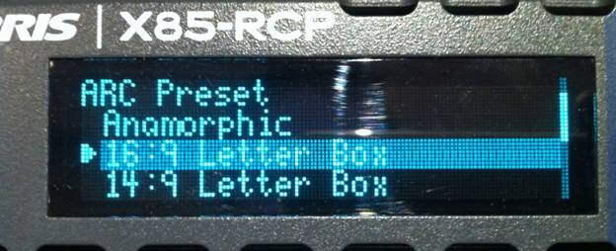

**Shuffling Audio**

From the **Main Menu v1.6**, scroll down and select **Audio.**

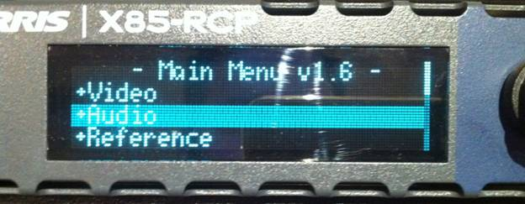

Scroll down and choose **Routing.**

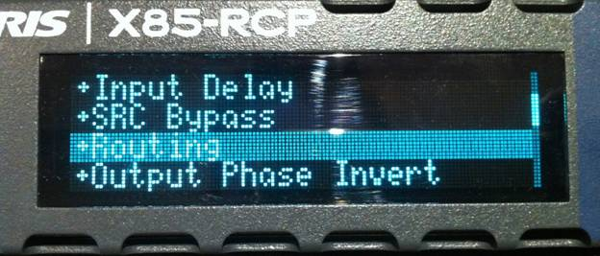

In the **Routing** Menu, you only want to use the top 4 Audio channels for Grp 1.

**SDI1Mux G1Ch1: DMX Grp1 Ch**

**SDI1Mux G1Ch2: DMX Grp1 Ch**

**SDI1Mux G1Ch3: DMX Grp1 Ch**

**SDI1Mux G1Ch4: DMX Grp1 Ch**

Select the Audio channel you wish to shuffle.

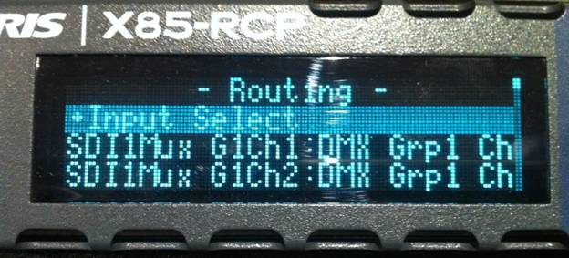

In the selected audio channel’s menu, you will be able to select from all 4 audio channels from your master in Grp 1 at the top of the menu.

**DMX Grp1 Ch1**

**DMX Grp1 Ch2**

**DMX Grp1 Ch3**

**DMX Grp1 Ch4**

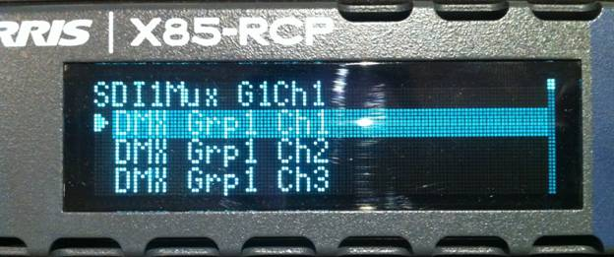

Select your channel by pressing in the scroll button or by pressing **enter**.